Linux Programming: assignment-8
- What is a user-defined function in shell scripting? Explain with an example.
  - A user defined function in shell scripting I a block of code written by user that performs a specific task and can be reused multiple times within the script.
  - It helps to make the script modular, readable and easier to maintain .
  - Syntax bash
function_name()
{
Commands
}
  - Example bash #!/bin/bash
greet_user()
{
echo "Hello, $1"
}
greet_user "PadmaShree"
  - Output css
Hello, PadmaShree
  - greet_user () : this is function name
  - $1: represents the 1st argument
  - Greet_user “PadmaShree” : calls the function and passes it
- Write a bash script with a function that multiply two integer numbers
  - bash
#!/bin/bash
echo ”enter the first number”
read num1
echo “enter the second number”
read num2
multiply()
{
result=$((num1*num2))
}
multiply
echo "The product of $num1and $num2 is: $result"
- Explain how arrays (1D, 2D, and 3D) are declared in bash scripting?
  - 1D array: It stores a list of elements under one variable name.
    - Declaring and inintialize arr=(10 20 30)
    - Assigning the values individually arr[0]=10 arr[1]=20 arr[3]=30
  - 2D array:Bash does not support 2D arrays directly, but we can simulate them using associative arrays or index patterns.
• Using index pattern bash declare -A matrix matrix[0,0]=1 matrix[0,1]=2
echo "matrix[0,0] = ${matrix[0,0]}" echo "matrix[0,1] = ${matrix[0,1]}"
  - 3D array: You can simulate a 3D array using associative array keys with three indices. bash declare -A cube cube[0,0,0] =1
cube[0,0,1]=2 cube[1,0,0]=3 cube[1,1,1]=4
echo "cube[0,0,1] = ${cube[0,0,1]}" echo "cube[1,1,1] = ${cube[1,1,1]}"
- Write a shell script to display elements of an array
  - bash
#!/bin/bash numbers=(10 20 30 40) echo ”the elements of the array are: “ for num in “${numbers[@]}” do echo “$num” done
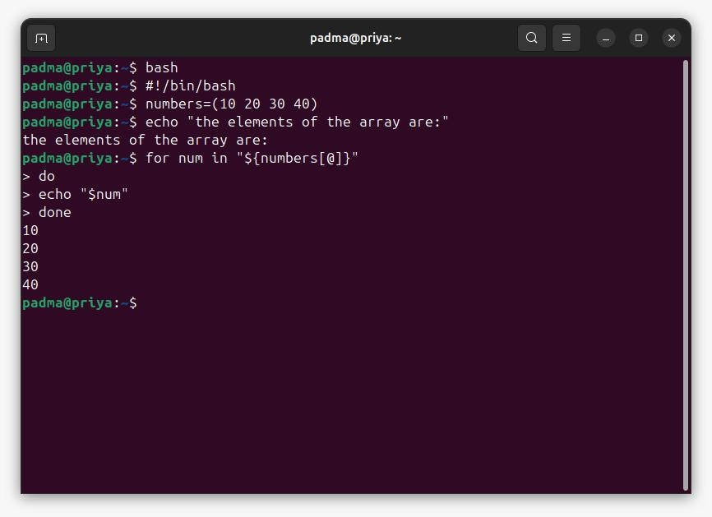0
- What is the purpose of cron in Linux?
  - The purpose of cron in linux is to schedule and do the task automatically which run at specific time.
- Write a cron job to run a backup script every day at midnight.
  - bash
crontab -e bash
0 0 * * * /home/user/backup.sh
Where,
0 : runs at minute 0
0 : runs at hour 0
    - : everyday
    - : every month * : everyday of the week
bash
chmod +x /home/user/backup.sh  example:
  - bash
#!/bin/bash
cp -r /home/user/Documents /home/user/backup/$(date +\%Y-\%m-\%d) echo "Backup completed on $(date)" >> /home/user/backup/backup.log
- How do you schedule a one-time job using at command?
  - the “at” command in the linux is used to schedule a one-time job to run a specific time or date.
  - bash
at [time]
- Write a script to display disk usage using df and du.
  - #!/bin/bash
echo "-----------------------------------------"
echo " Disk Usage Summary "
echo "-----------------------------------------"
echo echo "1⃣ Disk space usage (df command):" df -h echo echo "2⃣ Directory usage (du command):" du -h --max-depth=1 echo
echo "-----------------------------------------"
echo " Report generated on: $(date)"
echo "-----------------------------------------"
9. How can you log the output of a script using the tee command?
- We can log the output of a script using the tee command to both display the output on the screen and save it to a file at the same time.
- bash command | tee filename
- Log script output to a file : bash #!/bin/bash
echo "Disk Usage Report" | tee disk_log.txt df -h | tee -a disk_log.txt
du -h --max-depth=1 | tee -a disk_log.txt
echo "Report generated on: $(date)" | tee -a disk_log.txt  Log entire script output at once: bash
#!/bin/bash
{
echo "System Information Report" df -h
du -h --max-depth=1 echo "Generated on $(date)"
} | tee -a /home/user/system_report.log
10. Explain with an example how shell scripting can automate system administration tasks.
- Shell scripting automation means writing scripts that execute a series of linux commands automatically without any manual inputs.
- bash
#!/bin/bash
SOURCE_DIR="/home/user/Documents"
BACKUP_DIR="/home/user/backup" LOG_FILE="/home/user/backup/backup.log"
mkdir -p "$BACKUP_DIR"
cp -r "$SOURCE_DIR" "$BACKUP_DIR/backup_$(date +%Y-%m-%d_%H-
%M-%S)"
echo "Backup completed on $(date)" >> "$LOG_FILE" echo "Backup successful!"
- bash
0 0 * * * /home/user/system_backup.sh  How it works:
The scripts automatically creates a daily backup .
No manual inputs are required as cron runs it at midnight automatically.
The process is logged for auditing or troubleshooting.
It ensures that data is safe and consistency with minimal effort.
Name: Akshitha reddy
USN: ENG24CY0090
Roll no: 47
Section: 3C
-------------------------------------x--------------------x-------------------------------------

